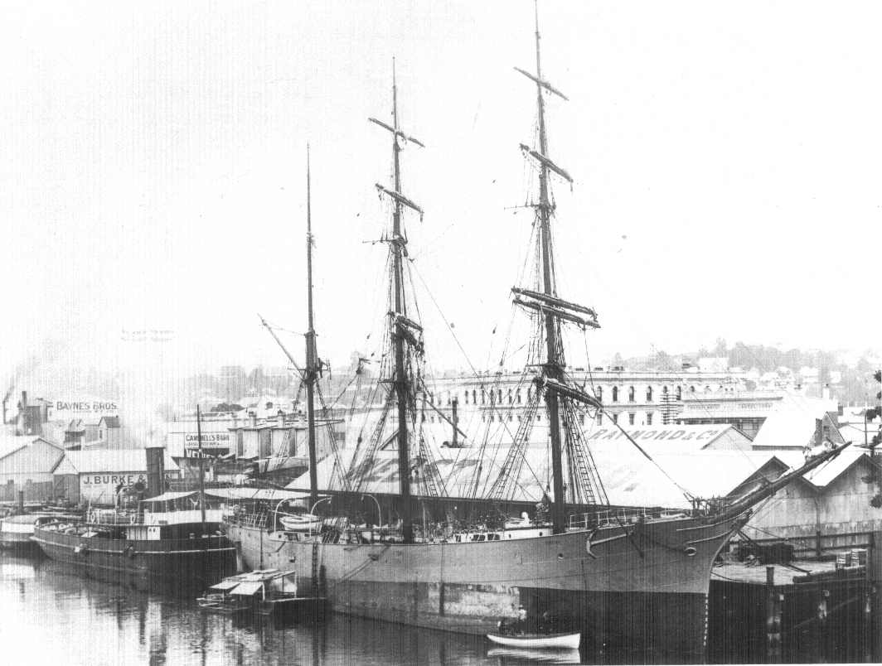

The barque Hirotha at Webster’s Wharf, South Brisbane, in 1902.
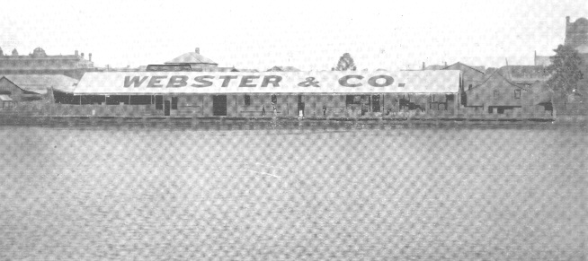 | 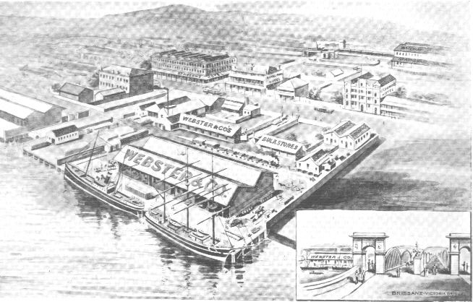
View from River | Overview
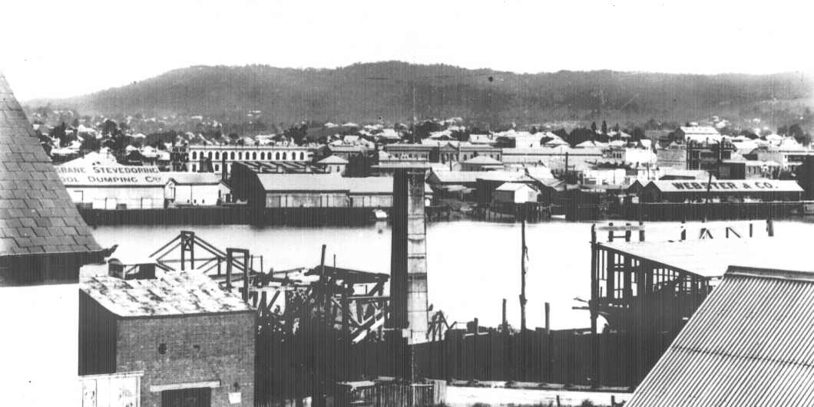

Webster’s Wharf, South Brisbane

