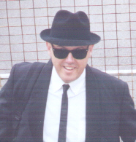

Rock’n’Roll Profile: Geoff Webster

Introduction

Hi, I’m one of the initiating forces behind this cruise concept.
How did this idea generate you may ask?
Well, the seeds for the idea of a cruise were sown back in 2002 when some friends went away on what they thought was a rock’n’roll cruise. They came back with stories of disappointment even though they had a good time. It was at that point I decided, “Let’s do it ourserlves, next time!”

At Wintersun 2003, the feedback I received about this idea was extremely favourable. Then, when P & O announced they were going to offer cruises out of Brisbane in 2004, the time had arrived to put words into action.

Dancing Background

Dancing is an activity I have always enjoyed even right back in my primary school days where we were taught old time dancing for the annual fancy dress ball. It was one of those social occasions that the whole town would support. The parents had just as much of a good time as us kids.

In High School, it was the Winter Ballroom dance classes and the school dances. Being a boarder (at a non co-ed school), I used to look forward to these occasions as you could no doubt guess why.

Having developed an interest in dancing, I started to go to social dance classes on an irregular basis in about 1980. It was at these ballroom dancing classes where I learnt to jive and it was this experience which sparked my passion for rock’n’roll.

I began to learn rock’n’roll back in 1995 with “Bayside Rockers” at the Mt Gravatt Bowls Club. This provided only a very brief introduction to the “Rockabilly” style as classes terminated after only a couple of weeks. Classes recommenced at the Holland Park Bowls Club where I was able to complete my course. Within a couple of months however, unfortunately these classes also ceased, but with a promise that classes would continue early the next year and I would be contacted.

In the following year I noticed a sign at the Newham Hotel in Wishart, saying “Rock’n’Roll Classes Here Every Tuesday Night”. A newly formed club called “HappyDay Rockers” had begun to hold classes there and so of course I started attending. Since then I have learnt a number of different dance styles. My obsession with rock’n’roll was sealed and as such you are assured of seeing me regularly in and around the various Brisbane rock’n’roll dances.

Professional Experience

When people ask me what do I do, I tell them “I teach”. Immediately they assume I’m a dance teacher. I still don’t know why they would think that. Actually, I teach within the Adult and Vocational Education system at TAFE in Business, Management and Marketing. All of my early working life was spent in private industry. My professional experience includes over 15 years in the building industry, 4 years in the medical and scientific field and over 10 years as a Marketing and Management Consultant with most recently as a business owner in the manufacturing sector for over 3 years. Other industries I also have experience in include sports facility marketing, property and hospitality. My level of involvement within these areas varied from sales and marketing, office administration, staff supervision, project management, training, business management and consulting. But since 1998 I have been a TAFE teacher endeavouring to impart some of my knowledge onto the young people of today.

Achievements & Accomplishments

Although I am not a competition dancer, I do have some notable accomplishments in Rock’n’Roll to date apart from this cruise. Firstly, in late 2000 I suggested to some friends that we enter a float in the annual Wintersun Parade, but not just any float, it needed to be different. My idea was for a “themed” float along a 50’s celebrities theme. With a small team we entered the “All-Star Café” in the 2001 Wintersun Parade. The float featured a 50’s style café complete with counter, tables and benches being frequented by a number a famous 50’s stars and celebrities. We didn’t win but it made the rock’n’roll clubs think more carefully about their floats. Ironically, the following year, a club adopted a “Jailhouse Rock” theme and won “Best Individual Float”.

Another notable achievement of mine would have to be the development of the face-to-face partner idea to the song “The Wanderer”. I suppose because of my original design training, I was taught to question everything. As a stir to confuse my friends one night in mid-2001, when “The Wanderer” started to play I decided to face them instead of being in the one line. With a bit of refining I came up with the “Springwood Rockers” version. As we regularly dance at the Springwood Bowls Club, hence the adaptation of the name. It was at a friends 50th birthday party later in 2001 that a pair of dance instructor friends saw us doing “our” version, liked it and started teaching the this version in their classes. The rest I guess is history as they say. I’m pleased to see that it has been further adapted.

Teaching Scope

As I now teach for a career, I have no real burning desire to teach rock’n’roll as well. I am just happy making up new moves. Comes with the attitude I think and it’s actually amazing how many new moves come from “mistakes”! I would have to say for me that the ultimate compliment would have to be dance instructors coming up and asking me to show them some of my moves. This I recall has happened on at least two occasions. I’m always especially pleased when I can remember how I’d done them in the first place.

Closing Remarks

All I can say is, “Long Live Rock’n’Roll”!

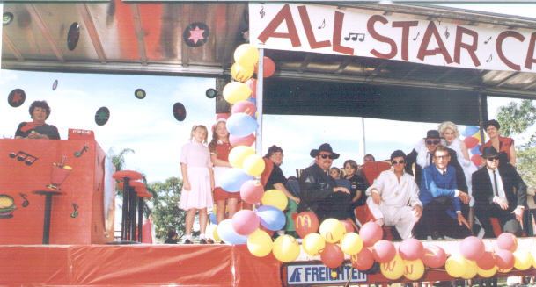

All Star Café Float –Wintersun 2001

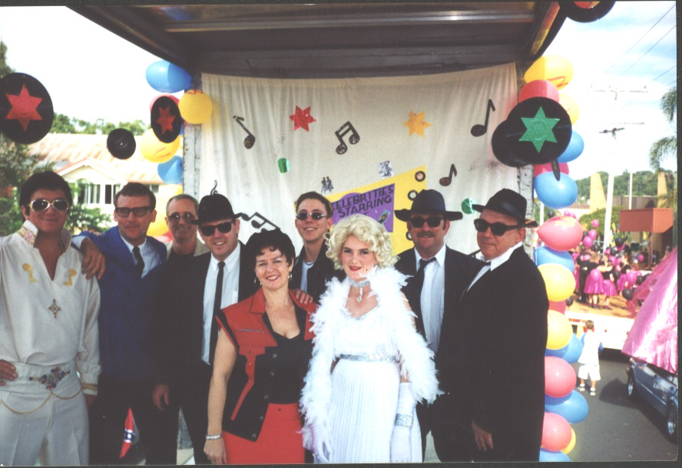 | 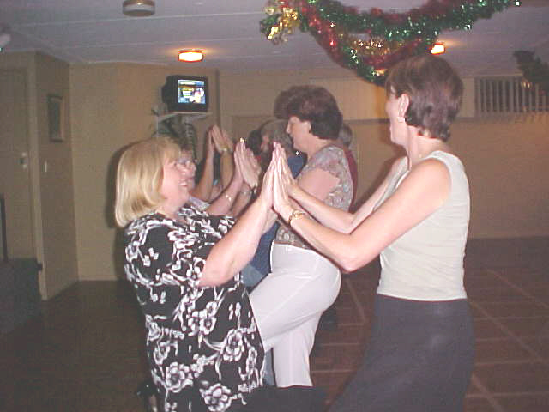
Famous Celebrities and Stars | “The Wanderer” – Springwood Rockers Version!
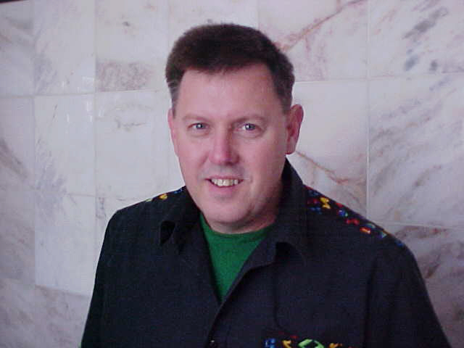

The Real Geoff Webster!

